**Table of Contents**

* Introduction
  + The Digital Revolution and Rise of Big Data
  + The Need for Distributed Computing
  + Overview of Cloud Technologies
* Prerequisite Concepts
  + Programming Paradigms: An Introduction
    - Procedural Programming
    - Object-Oriented Programming
    - Functional Programming
  + Introduction to Computer Architecture
    - Single Machine Structures
    - Computer Clusters and Distributed Systems
  + Essential Terminologies
    - Data Redundancy and High Availability
    - Virtual Machines and Containers
    - Scripting vs. Programming Languages
* Distributed Data Storage
  + Introduction to Distributed Storage
  + Hadoop: The Distributed File System
    - Architecture, Components, and Working
    - Real-world Use Cases
  + Real-time Data with HBase
  + Other Distributed Storage Solutions
* Data Processing & Analysis
  + MapReduce: Understanding Distributed Computing
  + Introduction to Apache Spark
    - RDDs, DataFrames, and Datasets
    - PySpark for Python Enthusiasts
  + Hive & Pig: High-Level Abstraction for Hadoop
  + Advanced Spark: Streaming, MLlib, and GraphX
* Cloud Platforms: The New Age Infrastructure
  + What is Cloud Computing?
  + Understanding IaaS, PaaS, and SaaS
  + Major Players: AWS, GCP, Azure
    - Overview, Services, and Comparison
    - Running Distributed Tasks on Cloud
  + Cost Management and Optimization in the Cloud
* Containers & Scalable Applications
  + The Need for Containerization
  + Introduction to Docker
  + Kubernetes: Orchestrating Containers
  + Deploying Distributed Systems with Containers
* Databricks & Unified Analytics
  + Introduction to Databricks Platform
  + Collaborative Data Science
  + Running Spark on Databricks
  + Delta Lake and Reliable Data Lakes
* Advanced Topics
  + Machine Learning at Scale with Spark
  + Real-time Analytics with Kafka and Spark Streaming
  + Graph Processing with Neo4j and Spark GraphX
* Case Studies and Real-world Applications
  + Big Data in Healthcare, Retail, and Finance
  + Real-time Analytics in Social Media
  + Personalized Recommendations with Distributed ML
* Future Trends & Conclusions
  + Quantum Computing & Big Data
  + AI-driven Big Data Processing
  + The Ethical Implications of Data Collection and Analysis

**Chapter 1: Introduction**

***1.1 The Digital Revolution and Rise of Big Data***

In the latter part of the 20th century, a profound shift took place - a shift from the industrial age to the digital age. This shift, often termed as the *Digital Revolution*, has transformed every facet of human existence. The Digital Revolution refers to the change from analog, mechanical, and electronic technology to digital technology. For instance, remember the transition from cassette tapes to CDs and, ultimately, to digital MP3s? That's a simple manifestation of this revolution.

The linchpin of the digital age is *data*. As businesses, governments, and individuals started to rely more on digital technologies, the amount of data generated skyrocketed. And it wasn’t just the volume; the variety of data sources also multiplied – from structured databases like your typical SQL tables to unstructured data like social media posts, images, and videos. The velocity at which data got generated also saw a massive spike, with real-time data streaming becoming commonplace.

This phenomenon of exponentially growing data in terms of volume, velocity, and variety is termed *Big Data*. To give you a clearer picture:

* Volume: Think about the vast amounts of user data that a platform like Facebook generates. It's not just about text but also images, videos, reactions, and more.
* Velocity: Consider Twitter, where millions of tweets, retweets, and likes occur every second around the globe.
* Variety: Amazon isn’t just storing data about which items you bought. It's tracking what you looked at, what you almost bought, what you liked, and much more.

With the rise of Big Data came the challenge: how do we effectively store, process, and derive insights from such vast amounts of information?

Example: Let's consider a Python dictionary, a common data structure, representing user activity on a hypothetical e-commerce site:

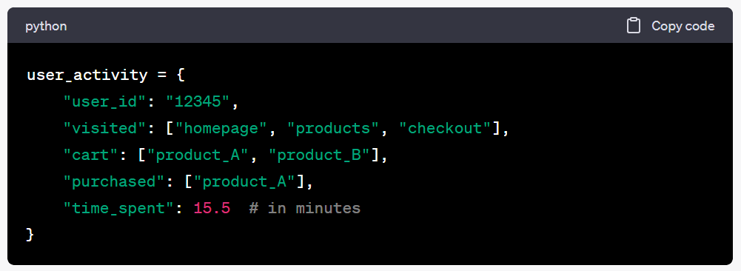

}

Now, imagine millions of such entries generated every minute. A single machine or a traditional database would find it hard to handle such load efficiently.

Exercise:

* Think about all the digital activities you did today. From checking your email to watching a video online, list down all these activities.
* For each activity, identify what kind of data you might have generated and in what format. For instance, watching a video might generate data about video watch time, pauses, and even volume adjustments.

***Study Questions:***

* What major technological shift occurred during the Digital Revolution?
* Define Big Data in terms of volume, velocity, and variety. Can you think of any other 'V's that might be relevant?
* Why is Big Data termed 'Big'? Is it just about the size?

***Real-world Case Study:*** *Netflix and Big Data*: Netflix uses Big Data analytics to improve its content recommendations to users. By analyzing the viewing habits of its users, Netflix recommends shows and movies you're more likely to watch. The data isn't just about what you watched, but also when you paused, what you skipped, and more. Such precise recommendations are a result of processing and analyzing vast amounts of user data, a feat only possible due to Big Data technologies.

In the sections that follow, we will delve deeper into how the challenges posed by Big Data led to the development and adoption of distributed computing frameworks and the evolution of cloud technologies.

***1.2 The Need for Distributed Computing***

The unprecedented growth of Big Data brought forth the realization that traditional computing systems were not equipped to handle this surge. The systems that worked perfectly for small to medium datasets suddenly felt sluggish and, in some cases, entirely unresponsive. Why?

Computers, in essence, have a processor (the brain), memory (short-term storage), and storage (long-term storage). When data grows beyond what the memory can handle, it spills over to the storage. Accessing data from storage is substantially slower than from memory. This results in noticeable slowdowns.

Additionally, when computational tasks become complex, a single processor may take an exceedingly long time to compute. In the worst cases, it might not be able to compute it at all within reasonable timeframes.

To tackle this, we needed a paradigm shift in how we processed data. Instead of trying to process all the data on one computer (often referred to as a node), what if we split the data into chunks and processed each chunk on a different computer simultaneously? This concept is the essence of Distributed Computing.

Distributed Computing is a field of computer science that studies distributed systems. A distributed system is a system whose components are located on different networked computers, which communicate and coordinate their actions by passing messages to one another. The components interact to achieve a common goal.

In simpler terms, imagine you had to count the number of words in a massive book. Instead of reading the book page by page yourself, you divide the book into chapters and distribute each chapter to a group of your friends. Each group counts the words in their assigned chapter simultaneously. In the end, you simply sum up the word counts from each group. This method is faster and more efficient, and this is, at a high level, how distributed computing works.

Example: Let's take the Python dictionary from before:

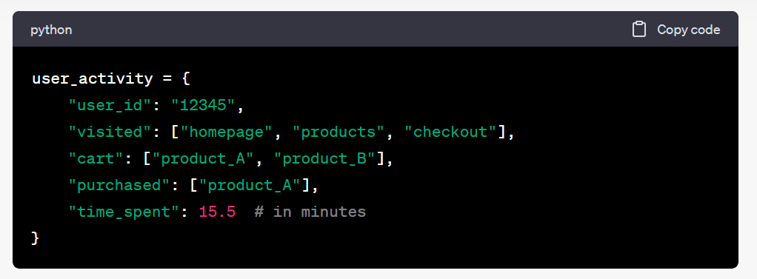

Now imagine having a billion of these. If we divide this dataset into 1000 parts and give each part to a separate computer to process, the task that would have taken 1000 minutes on one computer might only take 1 minute (assuming perfect parallelization, which is rarely the case, but it’s useful for illustration).

***Exercise:***

* Think about a common task you perform on your computer that takes a considerable amount of time. How would you divide that task if you had 10 computers at your disposal?
* Why is traditional computing inadequate for processing large datasets?
* What is the fundamental concept behind distributed computing?
* How does distributing a task across multiple nodes help in faster computation?

Real-world Case Study: *Google and Distributed Computing*: Google, handling enormous amounts of data every second, is a pioneer in distributed computing. Their foundational paper on the Google File System in 2003 shed light on how they stored vast amounts of data. Following that, in 2004, they introduced the concept of MapReduce, a model that allows for the processing of large datasets with a parallel and distributed algorithm on a cluster.

In the next section, we will explore how the advancement of distributed computing frameworks has been supported and amplified by the proliferation of cloud technologies, making big data processing more accessible than ever.

***1.3 Overview of Cloud Technologies***

In the late 20th and early 21st centuries, as data began to grow exponentially and the need for distributed computing became evident, another groundbreaking advancement took place: the development and widespread adoption of cloud technologies. But what exactly is "the cloud"?

At its core, the cloud refers to servers that are accessed over the Internet, and the software and databases that run on those servers. Instead of keeping files on a proprietary hard drive or local storage, cloud-based storage makes it possible to save them to a remote database. These servers, maintained by cloud service providers, have far-reaching advantages, from scalability to cost efficiency.

Scalability: In traditional setups, if you needed more computing resources, you'd have to manually set up additional servers or storage devices. With cloud technologies, you can often scale resources up or down almost instantly, depending on your needs.

Cost Efficiency: Instead of investing in physical hardware and infrastructure, businesses and individuals can rent computing resources as needed. This is particularly useful for startups or projects with fluctuating resource requirements.

The major types of cloud services include:

* Infrastructure as a Service (IaaS): This service provides virtualized computing resources over the Internet. Think of IaaS as leasing a fully serviced flat, where all infrastructure concerns are taken care of for you. For instance, if you're a software developer, you can rent virtual computers on which you run your applications. These resources are scalable, so if your application gets more users and you need more resources, you can scale up accordingly.
* Platform as a Service (PaaS): PaaS provides a platform allowing customers to develop, run, and manage applications without the complexity of building and maintaining the infrastructure. Imagine wanting to bake a cake (your application) without having to buy all the ingredients individually or even own an oven. A PaaS provides you with the whole kitchen setup, so you can just focus on baking.
* Software as a Service (SaaS): SaaS delivers applications over the Internet without the need to install them on individual computers. Think of it like streaming a movie on Netflix instead of buying a DVD. Common examples include email services like Gmail or productivity software suites like Microsoft 365.

Example: If you've ever used Google Drive or Dropbox, you're already familiar with a version of SaaS. These platforms allow you to store your documents on the cloud, ensuring they're backed up and can be accessed from anywhere, without having to install specific software on your computer.

***Exercise:***

Can you list down five tasks you perform daily that rely on cloud technologies?

***Study Questions:***

* How do cloud technologies differ from traditional computing?
* What are the major types of cloud services, and how do they differ from each other?
* Why might a business choose to use cloud technologies over traditional setups?

Real-world Case Study: *Netflix and Cloud Computing*: Netflix, one of the world's biggest on-demand streaming services, heavily relies on cloud technologies. In the early 2010s, Netflix moved all its operations, including databases, application servers, and even their recommendation engine, to the cloud. By utilizing Amazon Web Services (AWS), Netflix can effortlessly handle millions of users streaming daily, scale resources as needed, and even expand to new regions without major investments in physical infrastructure.

References:

Mayer-Schönberger, V., & Cukier, K. (2013). Big data: A revolution that will transform how we live, work, and think. Houghton Mifflin Harcourt.

Wu, X., Zhu, X., Wu, G. Q., & Ding, W. (2014). Data mining with big data. IEEE transactions on knowledge and data engineering, 26(1), 97-107.

Netflix TechBlog. (2016). Completing the Netflix Cloud Migration. [Medium Article](https://netflixtechblog.com/completing-the-netflix-cloud-migration-5c20b0ab95fa).

Mell, P., & Grance, T. (2011). The NIST definition of cloud computing.

Ghemawat, S., Gobioff, H., & Leung, S. T. (2003). The Google file system. ACM SIGOPS operating systems review, 37(5), 29-43.

Dean, J., & Ghemawat, S. (2008). MapReduce: simplified data processing on large clusters. Communications of the ACM, 51(1), 107-113.The subsequent sections will dive deeper into the specific tools and platforms that have emerged in response to the challenges and opportunities presented by Big Data, distributed computing, and cloud technologies.